**MAHENDRA INSTITUTE OF TECHNOLOGY**

|  |  |  |  |  |  |  |  |  |  |  |  |
| --- | --- | --- | --- | --- | --- | --- | --- | --- | --- | --- | --- |
|  | **Smart Farmer-IOT Enabled Smart Farming Application**    **Technical Stack**   |  |  | | --- | --- | | **TITLE** | **Smart Farmer-IOT Enabled Smart Farming Application** | | **DOMAIN NAME** | INTERNET OF THINGS | | **TEAM ID** | PNT2022TMID22828 | | **LEADER NAME** | KOWSALYA D | | **TEAM MEMBER NAME** | KAMALAKANNAN R  KARTHICK S  NITHEEN V P | |

The Deliverable shall include the architectural diagram as below and the information as per the table1 & table 2

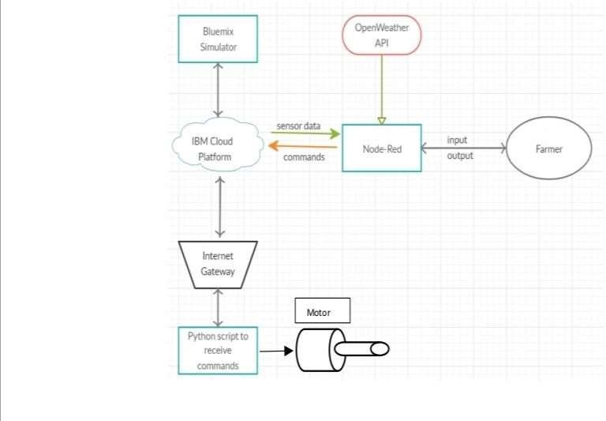

Guidelines:

1. Include all the processes (As an application logic / Technology Block)
2. Provide infrastructural demarcation (Local / Cloud)
3. Indicate external interfaces (third party API’s etc.)
4. Indicate Data Storage components / services
5. Indicate interface to machine learning models (if applicable)

* The different soil parameters temperature, soil moistures and then humidity are sensed using different sensors and obtained value is stored in the IBM cloud.
* Arduino UNO is used as a processing Unit that process the data obtained from the sensors and whether data from the weather API.
* NODE-RED is used as a programming tool to write the hardware, software, and APIs. The MQTT protocol is followed for the communication.
* All the collected data are provided to the user through a mobile application that was developed using the MIT app inventor. The user could decide through an app, weather to water the crop or not depending upon the sensor values. By using the app, they can remotely operate the motor switch.

**Table - 1:**

**Components & Technologies:**

|  |  |  |  |
| --- | --- | --- | --- |
| **S. No** | **Component** | **Description** | **Technology** |
| 1. | User Interface | How user interacts with application e.g. WebUI, Mobile App. | HTML, CSS, JavaScript / Angular Js / React Js etc. |
| 2. | Application Logic-1 | Logic for a process in the application | Python |
| 3. | Application Logic-2 | Logic for a process in the application | IBM Watson IOT service |
| 4. | Application Logic-3 | Logic for a process in the application | IBM Watson Assistant |
| 5. | Database | Data Type, Configurations etc. | MySQL, NoSQL, etc. |
| 6. | Cloud Database | Database Service on Cloud | IBM Cloud |
| 7. | File Storage | File storage requirements | IBM Block Storage or Other  Storage Service or Local File system |
| 8. | External API-1 | Purpose of External API used in the application | IBM Weather API, etc. |
|  |  |  |  |
| 9. | Machine Learning Model | Purpose of Machine Learning Model | Object Recognition Model, etc. |
| 10. | Infrastructure (Server / Cloud) | Application Deployment on Local System / Cloud Local Server Configuration:  Cloud Server Configuration: | Local, Cloud Foundry, Kubernetes, etc. |

**Table-2:**

**Application Characteristics:**

|  |  |  |  |
| --- | --- | --- | --- |
| **S. No** | **Characteristics** | **Description** | **Technology** |
| 1. | Open-Source Frameworks | List the open-source frameworks used | Technology of Open source framework |
| 2. | Security Implementations | Sensitive and private data must be protected from their production until the decision-making and storage Stages. | e.g. Node-Red, Open weather App API,MIT App Inventor, etc. |
| 3. | Scalable Architecture | Scalability is a major concern for IoT platforms. It has been shown that different architectural choices of IoT platforms affect system scalability and that automatic real time decision-making is feasible in an Environment composed of dozens of thousand. | Technology used |
| 4. | Availability | Automatic adjustment of farming equipment made possible by linking information like crops/weather and equipment to auto-adjust temperature, humidity, etc. | Technology used |
| 5. | Performance | The idea of implementing integrated sensors with sensing soil and environmental or ambient parameters  in farming will be more efficient for overall monitoring. | Technology used |